Docker Lifecycle & Change default location:

<https://medium.com/techmormo/the-docker-container-lifecycle-docker-made-easy-part-3-1452764263ca>

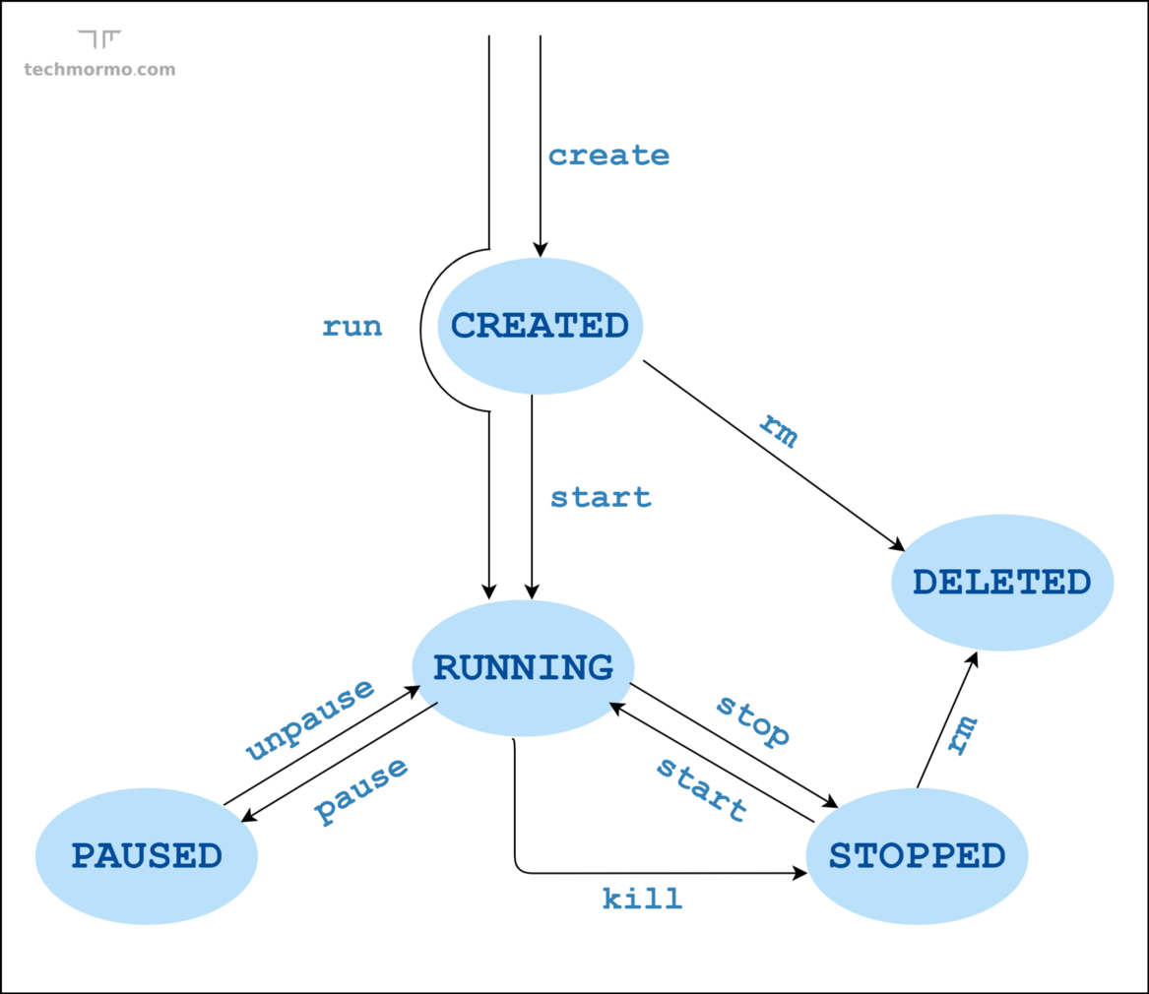

Changing Docker Default Directory:

<https://linuxconfig.org/how-to-move-docker-s-default-var-lib-docker-to-another-directory-on-ubuntu-debian-linux>

1. Create additional EBS Volume , fdisk and mount it.
2. sudo systemctl stop docker.service
3. sudo systemctl stop docker.socket
4. sudo nano /lib/systemd/system/docker.service

Add the following line with the custom directory



ExecStart=/usr/bin/dockerd --data-root /dockerdata -H fd:// --containerd=/run/containerd/containerd.sock

1. sudo rsync -aqxP /var/lib/docker/ /dockerdata/
2. sudo systemctl daemon-reload && sudo systemctl start docker
3. sudo systemctl status docker --no-pager
4. ps aux | grep -i docker | grep -v grep